CS 305 Project One

Document Revision History

Version | Date | Author | Comments
1.0 | 05/20/2026 | Jeremiah (Jay) Case | Initial vulnerability assessment report

Client



Instructions
Submit this completed vulnerability assessment report. Replace the bracketed text with the relevant information. In this report, identify your security vulnerability findings and recommend the next steps to remedy the issues you have found.

- Respond to the five steps outlined below and include your findings.
- Respond using your own words. You may also include images or supporting materials. If you include them, make certain to insert them in the relevant locations in the document.
- Refer to the Project One Guidelines and Rubric for more detailed instructions about each section of the template.

Developer
Jeremiah (Jay) Case

1. Interpreting Client Needs

Determine your client’s needs and potential threats and attacks associated with the company’s application and software security requirements. Consider the following questions regarding how companies protect against external threats based on the scenario information:

- What is the value of secure communications to the company?
- Are there any international transactions that the company produces?
- Are there governmental restrictions on secure communications to consider?
- What external threats might be present now and in the immediate future?
- What modernization requirements must be considered, such as the role of open-source libraries and evolving web application technologies?

Artemis Financial handles sensitive customer financial information, including retirement, investment, savings, and insurance data. Because of this, secure communication is essential to protect customer privacy, maintain trust, and prevent data breaches or financial fraud.

The company may communicate or conduct transactions internationally, which means it must consider regulations related to data protection and secure communications, such as GDPR and PCI-DSS compliance requirements.

Several external cybersecurity threats could impact the application now and, in the future, include:

- SQL injection attacks
- Cross-site scripting (XSS)
- Man-in-the-middle (MITM) attacks
- Credential theft
- Remote code execution attacks
- Distributed denial-of-service (DDoS) attacks

Since Artemis Financial uses a RESTful web application API, secure API communication and authentication are important.

2. Areas of Security
Refer to the vulnerability assessment process flow diagram. Identify which areas of security apply to Artemis Financial’s software application. Justify your reasoning for why each area is relevant to the software application.

Based on the vulnerability assessment process flow diagram, several areas of security apply to Artemis Financial’s web application.

- Input Validation: Input validation is important because the application accepts user input through web forms and API requests. Proper validation helps prevent attacks such as SQL injections and malicious input exploitation.
- APIs: Artemis Financial uses a RESTful API, making secure API communication essential. APIs must securely handle authentication, requests, and sensitive customer data.

- Cryptography: Cryptography is necessary because the company stores and transmits confidential financial information. Encryption helps protect customer data from unauthorized access during communication and storage.

- Client/Server Security: The application operates in a client-server environment, so secure communication protocols such as HTTPS and TLS are required to protect transmitted data from interception or tampering.

- Code Error Handling: Secure error handling is important because detailed system errors or stack traces could expose sensitive information to attackers. Error messages should be limited and properly managed.

- Code Quality: Secure coding practices help reduce vulnerabilities caused by poor programming techniques, insecure logic, or outdated code.

- Encapsulation: Encapsulation helps protect sensitive data and internal application components by restricting unauthorized access to system resources and data structures.

3. Manual Review
Continue working through the vulnerability assessment process flow diagram. Identify all vulnerabilities in the code base by manually inspecting the code.

- Hardcoded database credentials – In DocData.java, the database username and password are hardcoded as “root” and “root”. This is insecure because anyone with access to the code could gain database access.

- Insecure database connection – DocData.java connects to MySQL using jdbc:mysql://localhost:3306/test without requiring encryption. Database communication should use secure connection settings when sensitive data is involved.

- Poor exception handling – Data.java uses e.printStackTrace(). This could expose internal system details if errors are logged or displayed.

- Missing input validation – CRUDController.java accepts the business_name request parameter without validating or sanitizing it. This could create risk if the input is later used in database queries or business logic.

- Unprotected API endpoint – The /read endpoint in CRUDController.java does not require authentication or authorization. Sensitive financial data should not be accessible through open endpoints.

- Reflected user input risk – GreetingController.java returns user-provided input from the name parameter in the API response. Without validation or encoding, this could create a cross-site scripting risk depending on how the response is displayed by a client.

- Weak encapsulation – In customer.java, account_balance has default/package-level access instead of being private. Sensitive financial data should be private and only modified through controlled methods.

- No validation on financial transactions – The deposit() method in customer.java does not validate the deposit amount. Negative or invalid values could incorrectly change the account balance.

- Large upload limits – In application.properties, file uploads are allowed up to 200 MB with a request size of 215 MB. This could increase the risk of denial-of-service attacks if upload controls are not added.

- Outdated or vulnerable dependencies – The pom.xml file uses older dependencies, including Spring Boot 2.2.4 RELEASE and Bouncy Castle 1.46. Outdated libraries may contain known vulnerabilities and should be updated.

4. Static Testing
Run a dependency check on Artemis Financial’s software application to identify all security vulnerabilities in the code. Record the output from the dependency-check report. Include the following items:

- The names or vulnerability codes of the known vulnerabilities
- A brief description and recommended solutions provided by the dependency-check report
- Any attribution that documents how this vulnerability has been identified or documented previously

The OWASP Dependency-Check scan identified multiple vulnerable dependencies with medium, high, and critical severity ratings.

Dependency | Vulnerability | Description | Recommended Solution
Bcprov-jdk15on-1.46.jar | CVE-2016-1000338  CVE-2020-15522  CVE-2023-33202  CVE-2015-7940 | Outdated Bouncy Castle cryptography library with known security weakness | Upgrade to the latest supported Bouncy Castle version
Hibernate-validator-6.0.18.Final.jar | CVE-2023-1932  CVE-2025-35036  CVE-2020-10693 | Validation framework contains known vulnerabilities | Update Hibernate Validator to a newer secure release
Jackson-databind-2.10.2.jar | CVE-2023-35116  CVE-2021-46877  CVE-2022-42004  CVE-2020-36518 | Jackson Databind contains multiple deserialization vulnerabilities | Upgrade Jackson Databind to the latest secure version
Log4j-api-2.12.1.jar | CVE-2026-34479  CVE-2026-34477  CVE-2020-9488 | Apache Log4j contains known logging vulnerabilities | Update Log4j to version 2.17.1 or later
Logback-core-1.2.3.jar | CVE-2023-6378  CVE-2021-42550 | Vulnerabilities exist in the Logback logging framework | Update Logback to the latest version
Snakeyaml-1.25.jar | CVE-2022-1471  CVE-2017-18640  CVE-2022-25857  CVE-2022-38749  CVE-2022-38751 | SnakeYAML contains unsafe deserialization vulnerabilities | Upgrade SnakeYAML to a patched version
Spring-boot-2.2.4.RELEASE.jar | CVE-2023-20873  CVE-2026-22733  CVE-2022-27772  CVE-2023-20883  CVE-2026-40972  CVE-2026-40975  CVE-2026-40973  CVE-2026-40977 | Spring Boot contains multiple known vulnerabilities | Update Spring Boot to a current supported release
Spring-core-5.2.3.RELEASE.jar | CVE-2022-22965  CVE-2024-22259  CVE-2021-22118  CVE-2020-5421  CVE-2022-22950  CVE-2022-22971  CVE-2023-20861  CVE-2023-20863  CVE-2026-22735 | Spring Boot contains several publicly disclosed vulnerabilities | Update Spring Framework dependencies
Spring-web-5.2.3.RELEASE.jar | CVE-2016-1000027  CVE-2022-22965  CVE-2024-22259  CVE-2021-22118  CVE-2020-5421  CVE-2022-22950  CVE-2022-22971  CVE-2023-20861  CVE-2023-20863  CVE-2026-22735 | Spring Web contains remote exploitation vulnerabilities | Update Spring Web to the latest secure version
Tomcat-embed-core-9.0.30.jar | CVE-2020-1938  CVE-2024-50379  CVE-2024-52316  CVE-2024-56337  CVE-2021-25122  CVE-2020-9484 | Embedded Tomcat contains multiple critical vulnerabilities | Update Tomcat dependencies
Tomcat-embed-websocket-9.0.30.jar | CVE-2020-1938  CVE-2024-5379  CVE-2020-8022 | WebSocket implementation contains security vulnerabilities | Upgrade Tomcat WebSocket components

Many of the vulnerabilities identified in the report are publicly documented in the National Vulnerability Database (NVD) and OWASP vulnerability databases. Several vulnerabilities involve unsafe deserialization, remote code execution risks, logging vulnerabilities, and outdated framework components.

The dependency-check report demonstrates the importance of maintaining updated dependencies and regularly performing vulnerability scans on web applications.

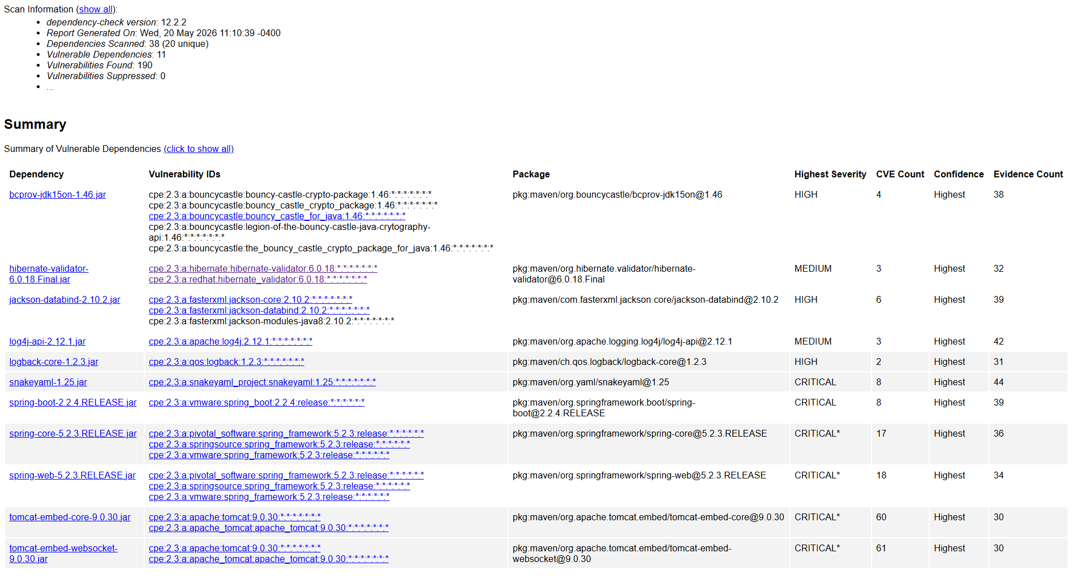

5. Mitigation Plan
Interpret the results from the manual review and static testing report. Then identify the steps to mitigate the identified security vulnerabilities for Artemis Financial’s software application.

Based on the results of the manual review and static testing report, Artemis Financial should implement several mitigation strategies to reduce security risks and strengthen application security.
Vulnerability | Recommended Mitigation
Hardcoded credentials | Store credentials in secure environment variables or encrypted configuration files instead of directly in source code
Missing input validation | Implement strict server-side input validation and sanitization for all user input
Weak error handling | Replace detailed stack traces with generic error messages to prevent information disclosure
Unsecured API endpoints | Require authentication and authorization for all sensitive API requests
Weak encapsulation of sensitive data | Change sensitive variables to private access and use controlled getter/setter methods
Lack of transaction validation | Validate deposit and financial transaction values before processing
Large file upload limits | Reduce upload size limits and implement upload filtering protections
Outdated dependencies | Regularly update dependencies and remove unsupported libraries
Vulnerable Spring Framework components | Upgrade Spring Boot, Spring Core, and Spring Web to current secure versions
Logging vulnerabilities | Upgrade Log4j and Logback to secure patched versions
Unsafe deserialization vulnerabilities | Upgrade SnakeYAML and Jackson Databind libraries to patched releases
Vulnerable Tomcat components | Upgrade embedded Tomcat dependencies to supported secure versions
Weak cryptography libraries | Upgrade Bouncy Castle cryptography libraries to modern secure versions

Additional recommendations include:
- Enforce HTTPS and TLS encryption for all communications
- Perform regular dependency and vulnerability scans using OWASP Dependency-Check
- Conduct routine penetration testing and secure code reviews
- Apply security patches and updates regularly
- Implement strong authentication controls such as multi-factor authentication (MFA)
- Follow OWASP secure coding best practices during development

Implementing these mitigation steps will help Artemis Financial improve the confidentiality, integrity, and availability of customer financial data while reducing the likelihood of future cyberattacks.

